Week 14

**Question 1:**

**You are transporting some boxes through a tunnel, where each box is a parallelepiped,**

**and is characterized by its length, width and height.**

**The height of the tunnel 41 feet and the width can be assumed to be infinite. A box can be**

**carried through the tunnel only if its height is strictly less than the tunnel's height. Find the**

**volume of each box that can be successfully transported to the other end of the tunnel.**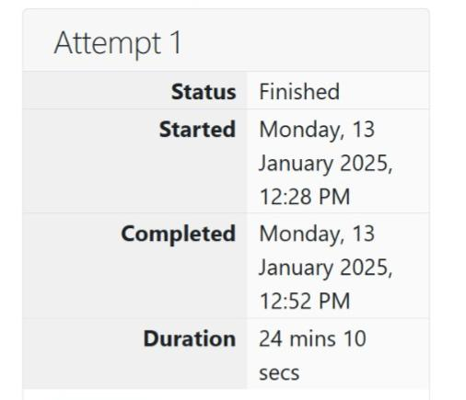

**Program:** 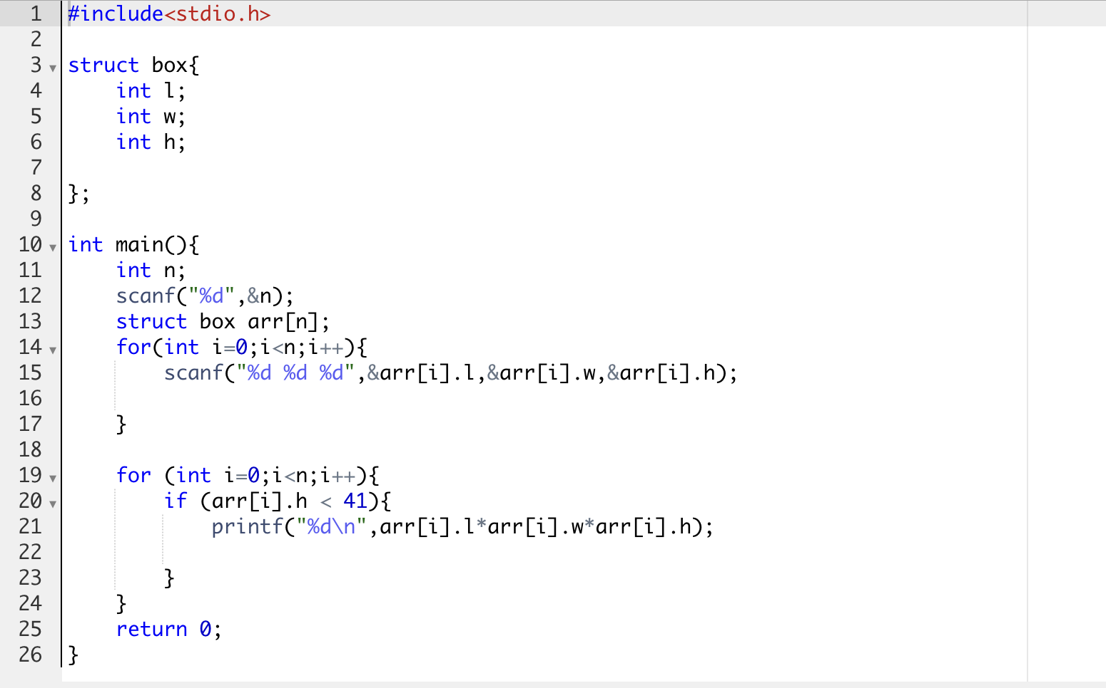

**Output:**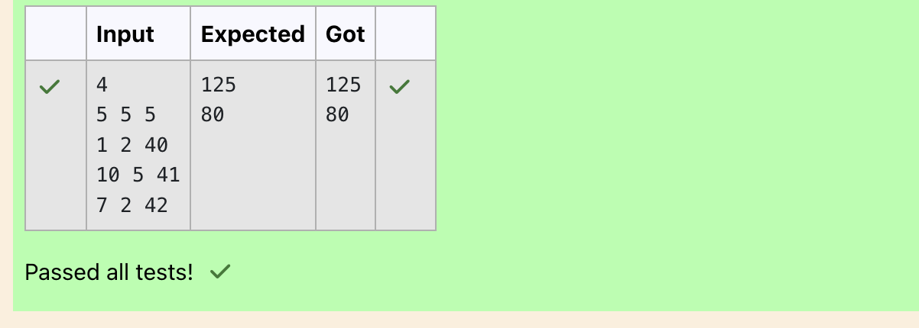

**Question 2:**

**You are given n triangles, specifically, their sides ai, bi and ci. Print them in the same style**

**but sorted by their areas from the smallest one to the largest one. It is guaranteed that all**

**the areas are different.**

**The best way to calculate a volume of the triangle with sides a, b and c is Heron's formula:**

**S = p * (p – a) * (p - b) * (p – c) where p = (a + b + c) / 2.**

**Program:** 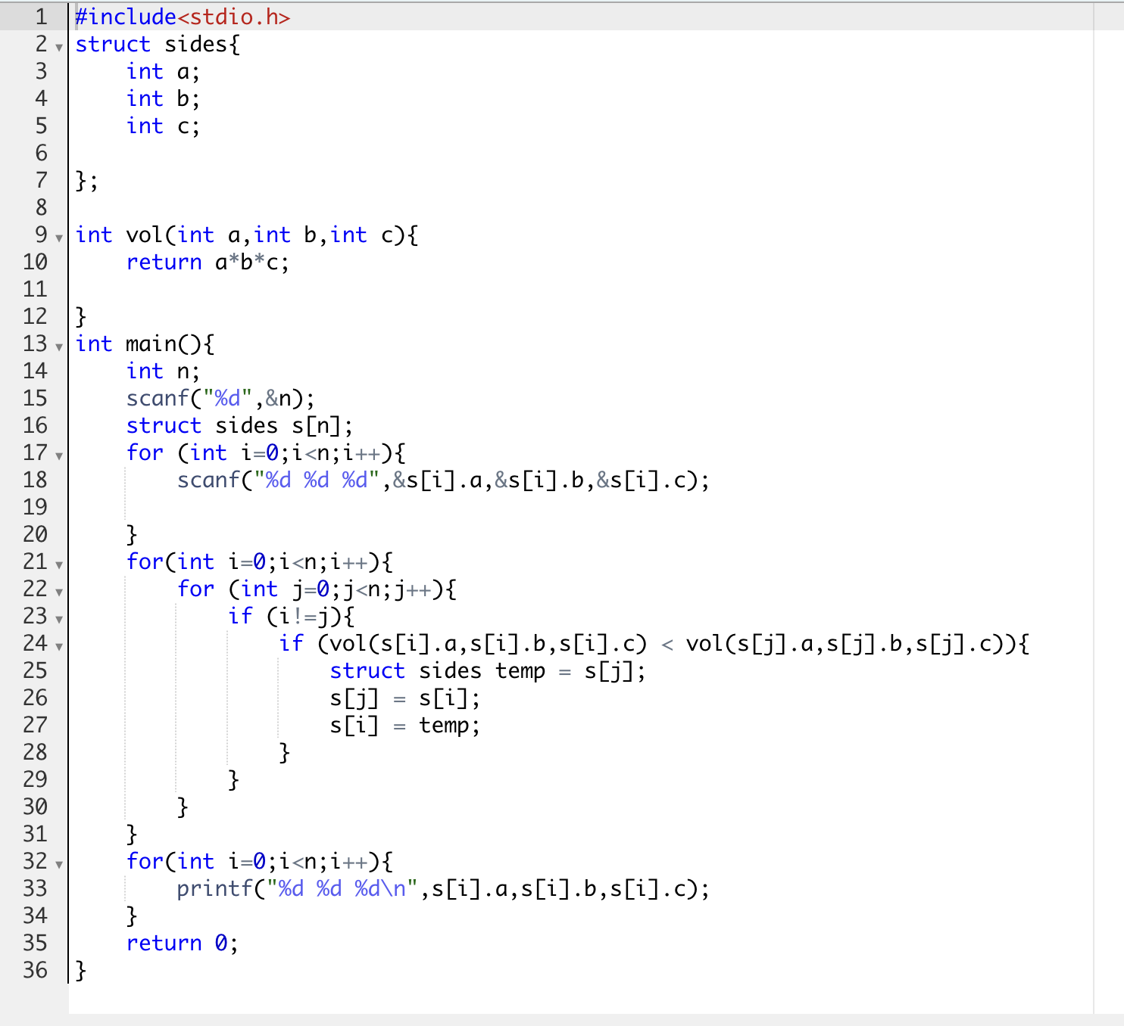

**Output:**

